Super Scrolling Shooter
(SSS)

CS437 Software Engineering

Functional Requirements and Design Document

Prepared by

Hao, Yuze
Harrison, Adrian
Nunez, Miguelangel
Razzak, Imtiaz

March 5, 2012

Super Scrolling Shooter
(SSS)

Prepared By:
Hao, Yuze
Harrison, Adrian
Nunez, Miguelangel
Razzak, Imtiaz

Approved By:

__________________ _____________
Jose Macias Date

Document Change Log

Update | Date Released | Changes
Draft #1 | 1/31/2012 | Delivery of the Software Requirements document
Draft #2 | 2/2/2012 | Update to Section 1, 2, and 3
Draft #3 | 2/24/2012 | Update to Section 6
Draft #4 | 3/2/2012 | Update to Section 4,5, and 6
Final Document | 3/20/2012 | Final Document Delivery

List of TBD Items

Page | Item | Description | Status
Section B | Data Dictionary | Completed Items | Completed on  3/2/2012
Section 3.2 | Complete the non-functional requirements. | Completed non-functional requirements | Completed on 2/2/2012
Section 3.3 | Complete the hardware requirements. | Completed hardware requirements | Completed on 2/2/2012
Section 6 | Requirements Test Table | Completed requirements test table | Completed on 3/2/2012
Table of Contents | Page Numbering | Completed numbering | Completed on  3/19/2012
Section 5 | Complete the implementation | Need to Complete a.s.a.p. | TBD
Table of Contents

1.0 INTRODUCTION
1.1 Purpose
1.2 Scope
1.2.1 Document Organization
1.2.2 Relationship to Other Documents
1.3 Project Name Architecture
1.3.1 Context Diagram (DFD Level 0)
1.3.2 Hardware and Software Considerations
1.4 Documentation Development Process
1.5 References
1.5.1 Controlling Documents
1.5.2 Applicable Documents
1.5.3 Standards
2.0 DETAILED FUNCTIONAL DESCRIPTION
2.1 Detailed SSS Functional Description.
2.1.1 High Level DFDs
2.1.2 Detailed Functional Description of the SSS Major Units.
3.0 THE SSS REQUIREMENTS
3.1 SSS Functional Requirements
3.2 SSS Non-Functional Requirements
3.3 SSS Hardware Requirements
4.0 SSS DETAILED DESIGN
5.0 SSS ELEMENTS OF IMPLEMENTATION
6.0 SSS TEST PLAN

List of Figures

Figure 1-1. Context Diagram (Level 0 Data Flow Diagram)
Figure 2-1. Level 1 Data Flow Diagram for the SSS System
Figure 4-1. Level 2 Data Flow Diagram for the Player Control module
Figure 4-2. Level 2 Data Flow Diagram for the Enemy Control module
Figure 4-3. Level 2 Data Flow Diagram for the Entity Processing module
Figure 4-4. Level 2 Data Flow Diagram for the Game Status Control module
Figure 4-5. Level 2 Data Flow Diagram for the Image Render and Audio Play module

List of Tables

Table 3-1. Requirements table for the Player Control module
Table 3-2. Requirements table for the Enemy Control module
Table 3-3. Requirements table for the Entity Processing module
Table 3-4. Requirements table for the Game Status Control module
Table 3-5. Requirements table for the Image Render and Audio Play module

Table 6-1. Test Plan table for the Player Control module
Table 6-2. Test Plan table for the Enemy Control module
Table 6-3. Test Plan table for the Entity Processing module
Table 6-4. Test Plan table for the Game Status Control module
Table 6-5. Test Plan table for the Image Render and Audio Play module
1.0 INTRODUCTION

1.1 Purpose

The purpose of this document is four-fold:

a) Define a full set of requirements for the SSS.
(These sections correspond to a Software Requirements Document, SRD).

b) Define the design for the SSS.
(These sections correspond to a Software Design Document, SDD)

c) Define the Test Plan for the SSS.
(These sections correspond to a Software Test Plan, STP).

d) Define/implement feasible modules for the SSS.
(These sections correspond to the Software Implementation Document, SID).

The complete definition of all SSS requirements provides the source requirement inputs for the development of the subsequent supporting software subsystems documents.

1.2 Scope

The scope of this document includes the following:

- All functional and non-functional requirements on the SSS are captured.
- A complete set of SSS Requirements, derived and traceable to the incoming class requirements. These requirements are organized by key SSS functional units shown on the Level 1 DFD given in section 2.0.
- A trace matrix, relating all SSS functional requirements to functional subunits as expanded in lower level DFDs. Higher level DFDs will be provided as part of the design in section 4.0
- The functional requirements defined in the SSS Requirements section have been expanded to include more specific hardware requirements.

1.2.1 Document Organization

The organization of this document provides a natural 'flow' or allocation of requirements to each succeeding section. Details regarding the overall document structure are discussed in sub-section 1.4.

1.2.2 Relationship to Other Documents

The SSS SRD is a complete self-contained document. Some relationships to other documents in the literature are indicated below in sub-section 1.5.

1.3 Project Name Architecture

1.3.1 Context Diagram (DFD Level 0)

The SSS architecture is summarized in the Context Diagram (DFD Level 0) given below. A more detailed Functional Description is given in Section 2 of this document.

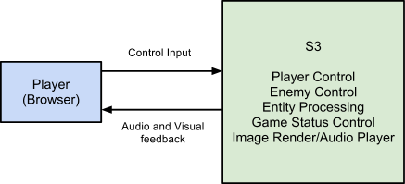
Figure 1-1

The foremost objective of SSS is to deliver a quality entertainment product that is easily accessible to web users. It will be built upon the Impact engine created by Dominic Szablewski. Impact is a javascript library that gives the developer a functional framework that provides efficient rendering and game entity handling.

SSS is a software application which provides major functions such as the ones listed below:

- It will provide challenges that will measure a player’s skill within the game.
- Adaptive enemy force
- Vertical scrolling shooter with an accessible set of controls utilizing the keyboard.
- Provides a visual interface that displays relevant player status information and score

SSS has unique features not offered by other systems with similar characteristics. These unique characteristics include:

- A Reactive enemy behavior determined by the player’s actions throughout a game session.

1.3.2 Hardware and Software Considerations

SSS needs a HTML5 supported web browser.

1.4 Documentation Development Process

The SSS detailed functional description is documented in Section 2. The overall detailed functional description is based on higher level DFDs (above level 1). All major functional units are described in detail in this part of the document.

Requirements affecting the SSS are captured in Section 3 of this document. It includes both functional and non-functional software requirements together with several detailed “rationale” paragraphs whenever necessary to complete the understanding of each requirement.

Section 4 is the SSS detailed Design Description Document (SDD). This part of the document includes all higher level DFDs as described in section 2 plus all interface units. The document is highly technical and it is based on Section 2 descriptions.

Section 5 includes elements of an implementation of the SSS. This section includes the various constraints that effectively limit the implementation as well as the sub-units that will be coded. The implementation goals are defined and the code and pseudo code are included as an attachment to this section.

Section 6 includes the overall test process for SSS. The test plan details the various techniques used to test the requirements and it also includes a Validation Matrix where each requirement specified in section 3 is listed with its corresponding validation method. In addition, the test plan specifies the mandated peer reviews needed to validate the stakeholders part of the requirements.

1.5 References

All references used in the creation of this document are listed below.

1.5.1 Controlling Documents

There is no document controlling this document.

1.5.2 Applicable Documents

No additional applicable document has been used in the production of this document.

1.5.3 Standards

No Standard has been used in the creation of this document. However, some Standards described in textbooks have been examined as a reference.

2.0 DETAILED FUNCTIONAL DESCRIPTION

2.1 Detailed SSS Functional Description.

The major tool used to design SSS is the Data Flow Diagram, DFD. The rationale behind the selection of DFDs as the preferred design tool was their simplicity and versatility. In the future more sophisticated tools may be used particularly if a stronger correlation from Design to Requirement to Implementation and Testing is required.

2.1.1 High Level DFDs

The SSS major functional subunits are shown in the DFD Level 1 depicted below:

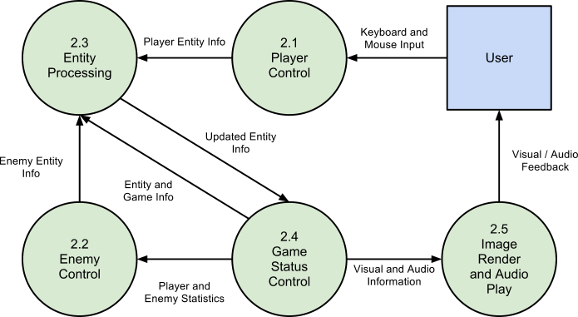

Figure 2-1

2.1.2 Detailed Functional Description of the SSS Major Units.

The description of the function of the SSS major functional units shown in Figure 2.1 follows.

Player Control – Module 2.1

This module will provide the user control over the player. This module will accept user input. It will also trigger corresponding commands, such as movement and attacking. This module will provide mouse/keyboard control over game menus.

Enemy Control – Module 2.2

This module will be in control of the enemies. This module will accept statistical data from the Game Status Module. This module will select formations for the enemies to take. This module will also randomly generate a path for the enemies to take that will stay in the game window. This module will also generate the commands for enemy attacks.

Entity Processing – Module 2.3
This module will have the core logic of the game. Input consists of movement commands and attack commands from both player and enemy control modules. This module will calculate and update the position of each entity. This module will check for collisions between entities. This module will have a timer that will determine the frequency of rendering and physics updates.

Game Status Control - Module 2.4
This module enforces the conditions and restrictions of the game. It will determine what kills the player and enemies. This module will keep track of statistics, such as average player position and enemy survival rate, to be fed to the enemy AI. Other values will be maintained, such as the current stage, victory conditions, and whether the game is started, paused or unpaused. This module will keep track of player lives.

Render Image/Play Audio - Module 2.5
This module, at the end of each iteration of the game loop, will render all visible entities. and play each activated sound.

3.0 THE SSS REQUIREMENTS

3.1 SSS Functional Requirements

This Section collects all the SSS Functional Requirements. This section includes the complete set of functional requirements with explanation and rational where the statement of the requirement was deemed insufficient or needing additional background/justification. All requirements relate to the design modules described in Section 2. An effort has been made to standardize the correlation between the design modules and the requirements to make their access and organization more consistent. For example, requirement number “n” affecting module 2.1 will be labeled 3.1-n.

 | 2.1- Player Control
Requirement No. | Requirement Description
 | 2.1.1 - Key Listening:
3.1-1 | SSS shall allow the user to move the player entity with a standard QWERTY keyboard.
3.1-2 | SSS shall allow the user perform attacks with a standard QWERTY keyboard.
3.1-3 | SSS shall allow the user to switch weapon types with a standard QWERTY keyboard.
3.1-4 | SSS shall allow the user to interact with menu in the game.
 | 2.1.2 - Menu Interface:
3.1-5 | SSS shall allow player to start the game by keyboard input.
3.1-6 | SSS shall allow player to pause game by keyboard input.
3.1-7 | SSS shall allow player to unpause(continue) game by mouse click if in paused menu.
3.1-8 | SSS shall allow player to restart game by mouse click if in paused menu.
3.1-9 | SSS shall allow player to return to main menu by mouse click if in paused menu.
 | 2.1.3 - Weapon Triggering:
3.1-10 | SSS shall initialize player weapon entity data.
 | 2.1.4 - Movement Control:
3.1-11 | SSS shall assign velocity of player entity.

 | 2.2 - Enemy Control
Requirement No. | Requirement Description
 | 2.2.1 - Tactics Processing:
3.2-1 | SSS shall choose the formation of an enemy type.
3.2-2 | SSS shall increase frequency of enemies based on score checkpoints.
3.2-3 | SSS shall choose the spawn location of enemy formations based on movement statistics.
 | SSS shall choose from predefined enemy attack types.
3.2-4 | SSS shall choose from predefined formations.
 | 2.2.2 - Weapon Triggering:
3.2-6 | SSS shall initialize enemy weapon entity data.
 | 2.2.3 - Formation Control:
3.2-7 | SSS shall generate formations of enemies.
3.2-8 | SSS shall change the frequency of formations.
 | 2.2.4 - Movement:
3.2-9 | SSS shall generate a random path for enemy entity.
3.2-10 | SSS shall choose paths based on the player’s position
3.2-11 | SSS shall define a path entirely contained by the game boundary.

 | 2.3 - Entity Processing
Requirement No. | Requirement Description
 | 2.3.1 - Entity Creation/Modification:
3.3-1 | SSS shall create all entities.
3.3-2 | SSS shall destroy defeated entities.
3.3-3 | SSS shall destroy off-screen entities.
3.3-4 | SSS shall update entities’ animation frames based on time since last animation frame change.
 | 2.3.2 - Physics processing
3.3-5 | SSS shall calculate every entity’s physics attributes.
3.3-6 | SSS shall update the physics variable of every entity.
 | 2.3.3 - Collision Check
3.3-7 | SSS shall determine if entities have collided with each other.
3.3-8 | SSS shall process the appropriate reactions of entity collisions based on predefined definitions.

 | 2.4 - Game Status Control:
Requirement No. | Requirement Description
 | 2.4.1 - Game Rules
3.4-1 | SSS shall store predefined victory/failure conditions.
3.4-2 | SSS shall end the game when victory/failure conditions have been met.
3.4-3 | SSS shall meet failure conditions when the player uses up all available lives.
3.4-4 | SSS shall meet victory conditions when the player defeats a final enemy.
3.4-5 | SSS shall maintain a timer for the game.
 | 2.4.2 - Interface
3.4-6 | SSS shall change the interface when the game is started.
3.4-7 | SSS shall change the interface when the game is paused or unpaused.
 | SSS shall change the stage and reset conditions when victory is achieved.
 | 2.4.3 - Statistics Keeping
3.4-8 | SSS shall count enemies that survive.
3.4-9 | SSS shall decrement the player’s available lives when the player is destroyed.
3.4-10 | SSS shall keep track of player position over time.

 | 2.5 - Image Render and Audio Player:
3.5-1 | SSS shall process image files to HTML5 canvas format.
3.5-2 | SSS shall display images on the the HTML5 canvas.
3.5-3 | SSS shall play predefined audio data when predefined conditions are met.

3.2 SSS Non-Functional Requirements

This Section collects all the SSS Non-Functional Requirements. All non-functional requirements are numbered “NF – n” where “n” indicates the n^{th} requirement.

NF - 1 SSS shall run at a minimum of 30 FPS with a computer with a dual core processor at 1.2GHz .
NF - 2 SSS shall provide a game focused on challenging the player.
NF - 3 SSS shall run smoothly on Opera and other browsers with similar Javascript performance.

3.3 SSS Hardware Requirements

This Section collects all the SSS Hardware Requirements. All hardware requirements are numbered “H – n” where “n” indicates the n^{th} requirement.

H - 1 Web server to serve html and javascript files to users.

4.0 SSS DETAILED DESIGN

In this section the SSS described in Section 2 with requirements listed in Section 3 will be designed in detail including several higher level DFDs. Each major module detailed design is included in correspondence with the design sections defined in Section 2 and responding to the requirements listed in its correlated sub-section in Section 3.

Player Control Level 2 DFD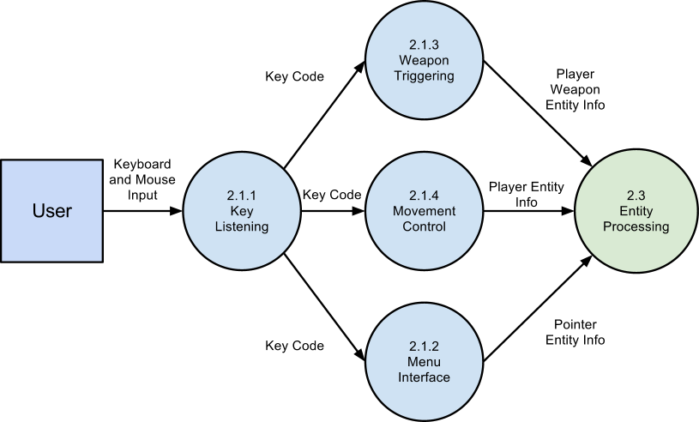

Figure 4-1

Enemy Control Level 2 DFD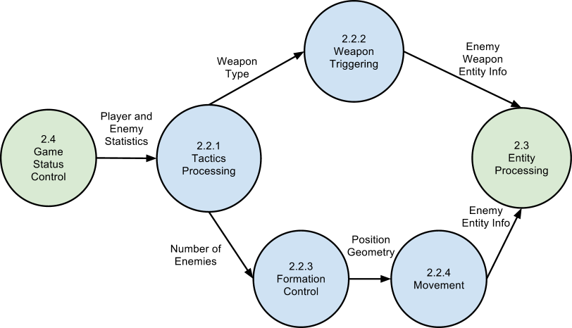

Figure 4-2

Entity Processing Level 2 DFD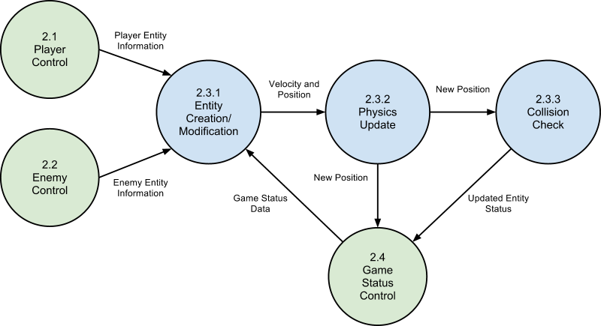

Figure 4-3

Game Status Control Level 2 DFD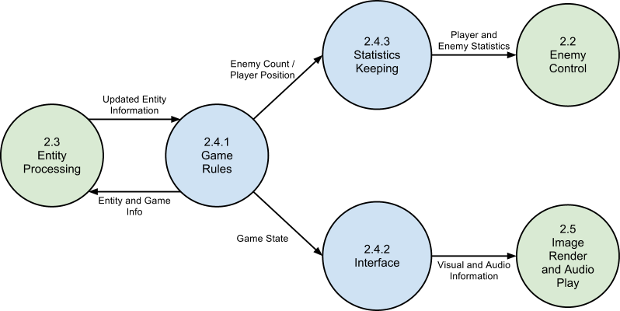

Figure 4-4

Image Render and Audio Play Level 2 DFD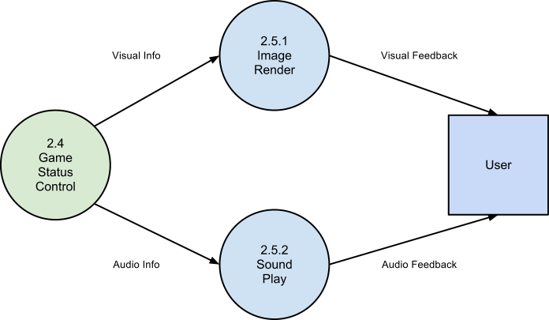

Figure 4-5

5.0 SSS ELEMENTS OF IMPLEMENTATION

In this section (some of) the modules designed in Section 4 with requirements listed in Section 3 will be implemented initially at the level of pseudo code. Actual code will be provided as time permits. Each module is implemented in correspondence with the design sections defined in section 2 and responding to the requirements listed in its correlated sub-section in chapter 3.

2.1 - Player Control

2.1.1
At initialization, key values are bound to input. The input state is periodically checked and dealt with accordingly.

ig.input.bind( ig.KEY.LEFT_ARROW, 'left');
ig.input.bind( ig.KEY.RIGHT_ARROW, 'right');
ig.input.bind(ig.KEY.SPACE, 'fire');
ig.input.bind(ig.KEY.ENTER, 'start');
ig.input.bind(ig.KEY.M, 'music');
ig.input.bind(ig.KEY.P, 'pause');
ig.input.bind(ig.KEY.MOUSE1, 'click');
2.1.2
The loop running the game is put in a paused state. The process running the game is not updated but not exited, so variables are maintained.

ig.main.pauseNow = function(game){
game.pause=true;
game.formTimer.pause = true;
ig.system.clock.pause = true;
ig.system.pause = true;
var wMid = ig.system.width/2;
var hMid = ig.system.height/2 - 22*2;
var settings;
for(var l = 0; l < 3; l++){
var height = hMid + l * 22;
settings = {option: l, ref: {x:wMid, y: height }};
game.menus.push(game.spawnEntity(Menu, 0, height,
settings));
}
for(var i=0; i < game.entities.length; i++){
ent = game.entities[i];
ent.pause=true;
if(ent.currentAnim != null){
ent.currentAnim.timer.pause = true;
ent.currentAnim.alpha = 0.45;
}
}

};
2.1.3
Input calls to create weapon object

fire: function(){
var shot;
switch(this.weaponType){
case 0: for(var i = 0; i <= 1; i++){ var pos = 9; if(i){
pos = 36;
} var settings = {flip: i};
shot = ig.game.spawnEntity( DoubleShot,
this.pos.x + pos,
this.pos.y + 4, settings ); } break; case 1:
for( var j = -1 ; j < 2; j++){
var velX = j * 100; var posX = (24 + j * 12) + this.pos.x; var posY = this.pos.y + 4; var settings = {vel: {x:velX, y:-500}, pos: {x:posX, y:posY}};
shot = ig.game.spawnEntity( SpreadShot, 0, 0, settings);
} break;
case 2:
shot = ig.game.spawnEntity( ApShot,
this.pos.x + 20,
this.pos.y + 4, settings );
break;
}
shot.sound.play();
},

2.1.4
Velocity value of player object is set. Speed is constant, user input alters the direction.

if(ig.input.state('left')){ if(this.pos.x > 1) this.vel.x -= 275
}
if(ig.input.state('right')){ if(this.pos.x < ig.system.width - this.size.x - 1) this.vel.x += 275;
}
2.2 - Enemy Control

2.2.1
Formations are chosen randomly, but weighted by statistics of performance against each enemy type. /
var f = Math.Random(ig.Stats.total);
if(f<ig.Stats.enemy[0]) formation = 1;
else if(f<ig.Stats.enemy[1]) formation = 2;
else if(f<ig.Stats.enemy[2]) formation = 3;
2.2.2
Timers in game status control frequency of creating weapon objects.
if(this.anims.open.loopCount){
this.anims.open.rewind();
this.currentAnim = this.anims.close.rewind();
ig.game.spawnEntity(EnemyShot, this.pos.x + this.size.x/2, this.pos.y+this.size.y/2);
}
2.2.3
The module creates the designated amount of enemies above the viewable space, then updates their position until another formation is created.
spawnFormation: function(f)
{ if(f==2)
{ var t = ig.game.spawnEntity(Enemy, ig.system.width/2, -64); this.dummy = ig.game.spawnEntity(Dummy, ig.system.width/2, -64);
this.enemyArr[0] = t;
for(var i=1; i<this.enemies; i++)
{ var s = ig.game.spawnEntity(Enemy, 24*Math.cos(i*2*this.pi/this.enemies)+ig.system.width/2, 24*Math.sin(i*2*this.pi/this.enemies)); this.enemyArr[i] = s; this.totalEnemyArr.push(s);
}
}

},

for(var i=1; i<this.enemies; i++) { this.enemyArr[i].pos.x = this.dummy.pos.x + 48*Math.cos(delta*5 + i*(2*this.pi/(this.enemies-1))); this.enemyArr[i].pos.y = this.dummy.pos.y + 48*Math.sin(delta*5 + i*(2*this.pi/(this.enemies-1)));
}
2.3 - Entity Processing

2.3.1
This module will call the necessary functions to spawn enemies/weapons. This module will also remove these objects from the game when their termination conditions have been met
spawnEntity: function( type, x, y, settings ) {
var entityClass = typeof(type) === 'string'
? ig.global[type]
: type;
if( !entityClass ) {
throw("Can't spawn entity of type " + type);
}
var ent = new (entityClass)( x, y, settings || {} );
this.entities.push( ent );
if( ent.name ) {
this.namedEntities[ent.name] = ent;
}
return ent;
},
removeEntity: function( ent ) {
// Remove this entity from the named entities
if( ent.name ) {
delete this.namedEntities[ent.name];
}
ent._killed = true;
ent.checkAgainst = ig.Entity.TYPE.NONE;
ent.collides = ig.Entity.COLLIDES.NEVER;
this._deferredKill.push( ent );
},
2.3.2
This module is built into the Impact game engine. This module receives current entity info and calculates new position info
update: function() {
if(!this.pause){
this.last.x = this.pos.x;
this.last.y = this.pos.y;
this.vel.y += ig.game.gravity * ig.system.tick * this.gravityFactor;
this.vel.x = this.getNewVelocity( this.vel.x, this.accel.x, this.friction.x, this.maxVel.x );
this.vel.y = this.getNewVelocity( this.vel.y, this.accel.y, this.friction.y, this.maxVel.y );
var mx = this.vel.x * ig.system.tick;
var my = this.vel.y * ig.system.tick;
var res = ig.game.collisionMap.trace(
this.pos.x, this.pos.y, mx, my, this.size.x, this.size.y
);
this.handleMovementTrace( res );
if( this.currentAnim ) {
this.currentAnim.update();
}
}
},

2.3.3
This module is built into the Impact game engine. This module will check the new position of objects and determine if a collision has occurred. Depending on the collision characteristics of the participating entities, entity destruction/modification may occur.
ig.Entity.checkPair = function( a, b ) {
if( a.checkAgainst & b.type ) {
a.check( b );
}
if( b.checkAgainst & a.type ) {
b.check( a );
}
if(
a.collides && b.collides &&
a.collides + b.collides > ig.Entity.COLLIDES.ACTIVE
) {
ig.Entity.solveCollision( a, b );
}
};

ig.Entity.solveCollision = function( a, b ) {

var weak = null;
if(
a.collides == ig.Entity.COLLIDES.LITE ||
b.collides == ig.Entity.COLLIDES.FIXED
) {
weak = a;
}
else if(
b.collides == ig.Entity.COLLIDES.LITE ||
a.collides == ig.Entity.COLLIDES.FIXED
) {
weak = b;
}

if(
a.last.x + a.size.x > b.last.x &&
a.last.x < b.last.x + b.size.x
) {

if( a.last.y < b.last.y ) {
ig.Entity.seperateOnYAxis( a, b, weak );
}
else {
ig.Entity.seperateOnYAxis( b, a, weak );
}
a.collideWith( b, 'y' );
b.collideWith( a, 'y' );
}
else if(
a.last.y + a.size.y > b.last.y &&
a.last.y < b.last.y + b.size.y
){
if( a.last.x < b.last.x ) {
ig.Entity.seperateOnXAxis( a, b, weak );
}
else {
ig.Entity.seperateOnXAxis( b, a, weak );
}
a.collideWith( b, 'x' );
b.collideWith( a, 'x' );
}
};

2.4 - Game Status

2.4.1
When the predetermined limit of player lives is lost, the game returns to the main menu.
//Within player module
kill: function(){
this.parent();
ig.game.menu = true;
}

2.4.2
At different states (game begin/end, paused/unpaused), this module will control applicable timers and entities to display appropriate menus.
if(ig.input.pressed('music')){ if(this.music){ this.music = false; ig.music.pause(); }else{ this.music = true; ig.music.play(); }
}
var ent;
if(ig.input.pressed('pause') && !this.menu){
if(this.pause) ig.main.unpause(this);
else ig.main.pauseNow(this);
}
if(ig.input.pressed('start')){
if(this.menu){
this.menu = false;
this.start();
}
}
2.4.3
This module will receive information from entities that are in the process of being destroyed. It will record relevant information to be retrieved by the Enemy AI.
removeEntity: function( ent ) {
// Remove this entity from the named entities
if( ent.name ) {
delete this.namedEntities[ent.name];
}
ent._killed = true;
ent.checkAgainst = ig.Entity.TYPE.NONE;
ent.collides = ig.Entity.COLLIDES.NEVER;
ig.Stats.count(ent);
this._deferredKill.push( ent );
},

2.5 - Render/Audio
draw: function(){
if( this.clearColor ) {
ig.system.clear( this.clearColor );
}
this._rscreen.x = Math.round(this.screen.x * ig.system.scale)/ig.system.scale;
this._rscreen.y = Math.round(this.screen.y * ig.system.scale)/ig.system.scale;
var mapIndex;
for( mapIndex = 0; mapIndex < this.backgroundMaps.length; mapIndex++ ) {
var map = this.backgroundMaps[mapIndex];
if( map.foreground ) { break;
}
map.setScreenPos( this.screen.x, this.screen.y );
map.draw();
}
this.drawEntities();
for( mapIndex; mapIndex < this.backgroundMaps.length; mapIndex++ ) {
var map = this.backgroundMaps[mapIndex];
map.setScreenPos( this.screen.x, this.screen.y );
map.draw();
}
},

6.0 SSS TEST PLAN

This Section contains all the SSS Functional Requirements Testing Methods. This section includes the complete set of functional requirements with the planned Testing Method for each function. An effort has been made to standardize the correlation between the design modules and the requirements to make their access and organization more consistent. For example, requirement number “n” affecting module 2.1 will be labeled 6.1-n.

 | 2.1- Player Control | Testing Method
Requirement No. | Requirement Description | Method Name
 | 2.1.1 - Key Listening:
6.1-1 | SSS shall allow the user to move the player entity with a standard QWERTY keyboard. | Analysis
6.1-2 | SSS shall allow the user perform attacks with a standard QWERTY keyboard. | Analysis
6.1-3 | SSS shall allow the user to switch weapon types with a standard QWERTY keyboard. | Analysis
6.1-4 | SSS shall allow the user to interact with menu in the game. | Analysis
 | 2.1.2 - Menu Interface:
6.1-5 | SSS shall allow player to start the game by keyboard input. | Analysis
6.1-6 | SSS shall allow player to pause game by keyboard input. | Analysis
6.1-7 | SSS shall allow player to unpause(continue) game by mouse click if in paused menu. | Analysis
6.1-8 | SSS shall allow player to restart game by mouse click if in paused menu. | Analysis
6.1-9 | SSS shall allow player to return to main menu by mouse click if in paused menu. | Analysis
 | 2.1.3 - Weapon Triggering:
6.1-10 | SSS shall initialize player weapon entity data. | Analysis
 | 2.1.4 - Movement Control:
6.1-11 | SSS shall assign velocity of player entity. | Analysis

 | 2.2 - Enemy Control | Testing Method
Requirement No. | Requirement Description | Method Name
 | 2.2.1 - Tactics Processing:
6.2-1 | SSS shall choose the formation of an enemy type. | Analysis
6.2-2 | SSS shall increase frequency of enemies based on score checkpoints. | Test
6.2-3 | SSS shall choose the spawn location of enemy formations based on movement statistics. | Test
6.2-4 | SSS shall choose from predefined enemy attack types. | Analysis
6.2-5 | SSS shall choose from predefined formations. | Analysis
 | 2.2.2 - Weapon Triggering:
6.2-6 | SSS shall initialize enemy weapon entity data. | Analysis
 | 2.2.3 - Formation Control:
6.2-7 | SSS shall generate formations of enemies. | Test
6.2-8 | SSS shall change the frequency of formations. | Test
 | 2.2.4 - Movement:
6.2-9 | SSS shall generate a random path for enemy entity. | Test
6.2-10 | SSS shall choose paths based on the player’s position | Analysis
6.2-11 | SSS shall define a path entirely contained by the game boundary. | Demonstration

 | 2.3 - Entity Processing | Testing Method
Requirement No. | Requirement Description | Method Name
 | 2.3.1 - Entity Creation/Modification:
6.3-1 | SSS shall create all entities. | Analysis
6.3-2 | SSS shall destroy defeated entities. | Analysis
6.3-3 | SSS shall destroy off-screen entities. | Test
6.3-4 | SSS shall update entities’ animation frames based on time since last animation frame change. | Demonstration
 | 2.3.2 - Physics processing
6.3-5 | SSS shall calculate every entity’s physics attributes. | Analysis
6.3-6 | SSS shall update the physics variable of every entity. | Analysis
 | 2.3.3 - Collision Check
6.3-7 | SSS shall determine if entities have collided with each other. | Test
6.3-8 | SSS shall process the appropriate reactions of entity collisions based on predefined definitions. | Test

 | 2.4 - Game Status Control: | Testing Method
 | 2.4.1 - Game Rules | Method Name
6.4-1 | SSS shall store predefined victory/failure conditions. | Analysis
6.4-2 | SSS shall end the game when victory/failure conditions have been met. | Test
6.4-3 | SSS shall meet failure conditions when the player uses up all available lives. | Test
6.4-4 | SSS shall meet victory conditions when the player defeats a final enemy. | Test
6.4-5 | SSS shall maintain a timer for the game. | Analysis
 | 2.4.2 - Interface
6.4-6 | SSS shall change the interface when the game is started. | Demonstration
6.4-7 | SSS shall change the interface when the game is paused or unpaused. | Demonstration
6.4-8 | SSS shall change the stage and reset conditions when victory is achieved. | Demonstration
 | 2.4.3 - Statistics Keeping
6.4-9 | SSS shall count enemies that survive. | Analysis
6.4-10 | SSS shall decrement the player’s available lives when the player is destroyed. | Analysis
6.4-11 | SSS shall keep track of player position over time. | Analysis

 | 2.5 - Image Render and Audio Player:
6.5-1 | SSS shall process image files to HTML5 canvas format. | Analysis
6.5-2 | SSS shall display images on the the HTML5 canvas. | Demonstration
6.5-3 | SSS shall play predefined audio data when predefined conditions are met. | Demonstration

A. ACRONYMS

SSS Super Scrolling Shooter
FPS Frames Per Second

B. DATA DICTIONARY

Entity - The player, the enemies, and all weapons are entities. They are units in the game that have physical attributes that are simulated in the game.
Level - The stage. It is the background art/music, and will end when the player has no lives left.
Physics - The formulas used to update player/enemy/weapon position. They do not necessarily obey realistic laws of physics.
Formation - The geometric layout of a set of enemies in addition to the path individual enemies take within a set of enemies
Weapon - An entity created by player and enemies alike, this entity destroys other entities on impact.

